www.e-hospital.co.uk

Author: Jennifer Bulcock www.jenniferbulcock.com

Publication Date: March 2017

The Children’s e-Hospital

Spring Diet Plan

Hot Cross Breakfast Buns
Shopping & Ingredients List:

2 tbsp olive oil
2 tsp cinnamon
2 eggs & 2 egg whites & 100ml skimmed milk beaten together

4 hot cross buns (60g size used in nutritional calculations - check labels)

Low Fat Greek yogurt to serve
Breakfast
Serves:4

A great energy boost to start the day, and embrace the joy of Hot Cross Buns - even at breakfast

Method
- Mix 2 tbsp of olive oil with half the cinnamon.
- Beat together the egg, milk, and remaining cinnamon
- drizzle the olive oil cinnamon mix over the open hot cross buns and sandwich together
- Dip each hot cross bun in the beaten eggs and leave to soak (this could all be done the night before)
- Cook the hot cross buns in a frying pan- while pushing down as you cook.
- Serve each portion with a tbs of Greek yogurt and a sprinkle of cinnamon

Macro info per serving
Protein |  | Carbs |  | Fat |  | Energy  275kcal
10g |  | 34g |  | 11g

Cheese Frittatta

Breakfast

Serves: 6
Shopping & Ingredients List: 7 large Eggs, beaten
325g Cheese, grated 2 tbsp Olive Oil

A simple savory choice which can be prepped ahead of time and even eaten cool whilst on the school run - if you're having one of 'those' mornings

Method
- Preheat grill to high. Beat cheese into the eggs.
- Heat oil in large non-stick frying pan. Add the egg mix. Stir with wooden spoon to eveny spread ingredients.
- Cook for 5-8 mins until golden brown & firm underneath. Then place pan under grill & cook for 4-5 mins to firm top.
- Slide frittata onto plate & cut into six wedges. Serve immediately.
- Can be cooled & wrapped in tin foil, stored in fridge for packed lunches too.

Macro info per serving
Protein
12.8g
Carbs
2.3g
Fat
22g
Energy
259kcal

Spring kids - baked eggs

Breakfast

Serves: 4
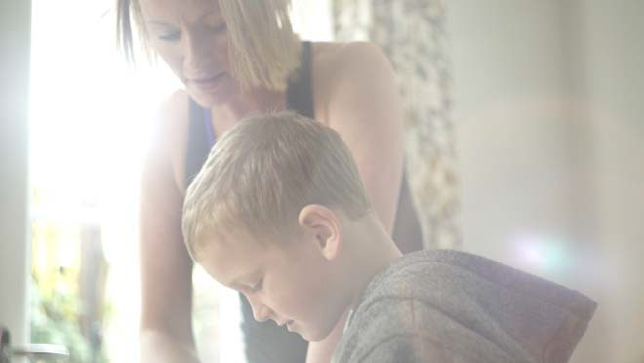

Getting kids excited about spinach is one of the biggest challenges parents can face. But by normalizing this as a food to be eaten at any time of day - including breakfast will help to build long term healthy lifestyle habits .

Shopping & Ingredients List:
100g Spinach
1 x 400g Tin Chopped Tomatoes
1 tsp Chilli Flakes
4 large Eggs
Can you eat spinach at breakfast?

Method
- Heat oven to 200c (180 fan), 400f, gas mark 6.
- Put spinach in colander & pour over kettle of boiling water to wilt leaves. Squeeze out excess water. Divide spinach between 4 small ovenproof dishes.
- Mix tomatoes with chilli flakes & add to the spinach dishes. Make a small well in centre of each dish & crack in one egg.
- Bake for 12-15 mins. Serve immediately.

Macro info per serving
Protein
9g
Carbs
3g
Fat
7g
Energy
114kcal

Easter Breakfast Bread

Breakfast
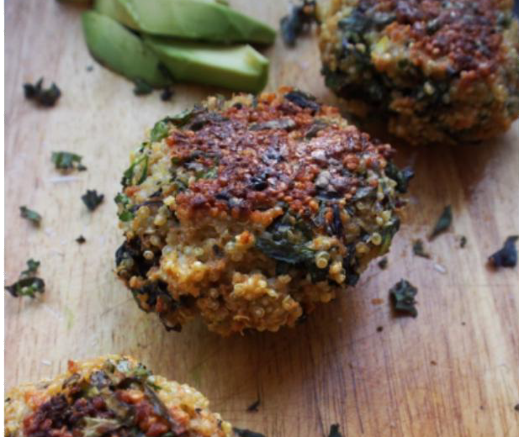
Serves: 2

Shopping & Ingredients List:
1 Cauliflower
1 small Onion, diced 25g Spinach
50g Mixed Nuts
3 Eggs
2 Garlic Cloves, crushed
1 tbsp fresh Parsley, chopped 2 tsp Coconut Oil

Easy to prep ahead of time for a quick and simple breakfast whilst on the go.

Method
- In a food processor chop white cauliflower head & nuts until it looks like breadcrumbs.
- In a large non-stick frying pan, stir-fry the cauliflower, onion & garlic for 10 mins.
- Preheat oven to 180c (160 fan), 350f, gas mark 4.
- In a bowl beat the eggs. Add spinach, herbs & cauliflower mix to the eggs.
- Line a baking sheet with greaseproof papaer. Spoon on egg mix & make into 6 circles. Bake for 15 mins. Serve immediately.

Macro info per serving
Protein
21g
Carbs
31.5g
Fat
26g
Energy
444kcal

Asparagus swords and Easter eggs

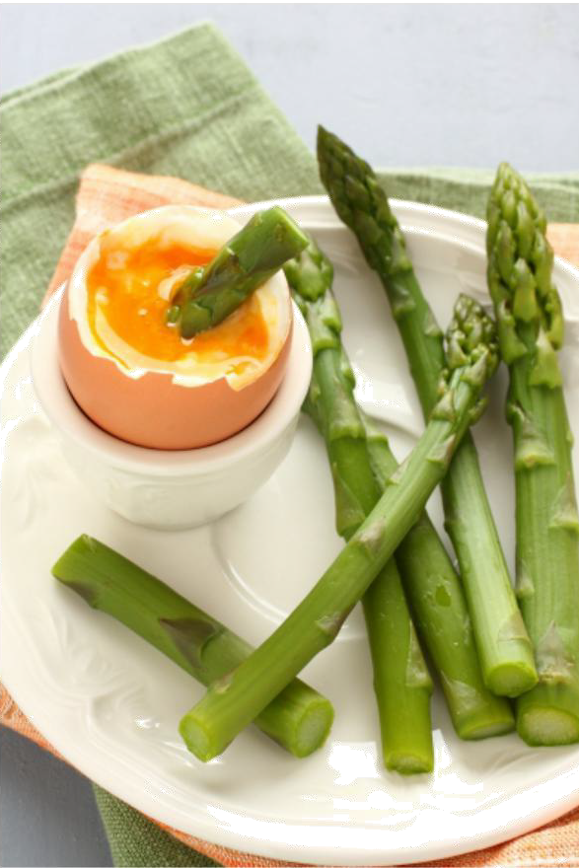
Breakfast
Serves: 1
Shopping & Ingredients List:
7g Almond Flour
½ tbsp Olive Oil 1 large Egg
4 Asparagus Spears
½ tsp Paprika
½ tsp Chilli

Asparagus goes incredibly well with a nice gooey egg, and is a great way to get a portion of veggies in at breakfast - plus kids love having asparagus sword fights at the breakfast table.
Method
- Heat oil in large non-stick frying pan. Add the almond flour & fry until crisp & brown.
Season with spices. Leave to cool.
- Cook asparagus in large pan of boiling salted water for 3 mins.
- At same time boil eggs for 3-4 mins.
- Drain the asparagus. Place on plate, sprinkle over the ‘breadcrumbs’. Place egg in egg cup
- Use asparagus to dip into soft boiled egg.

*If the kids are adverse to the green swords, don't despair, keep serving them, but have the option of wholemeal toast too. If you stop offering certain foods, they may struggle to develop the skills to explore new tastes.
It can take up to 16 new attempts at tasting a new food before we start to develop a liking to a new taste.

Macro info per serving

Protein |  | Carbs |  | Fat |  | Energy  204kcal
10g |  | 5g |  | 16g

Rhubarb Breakfast Overnight Oats

Breakfast

Serves: 4
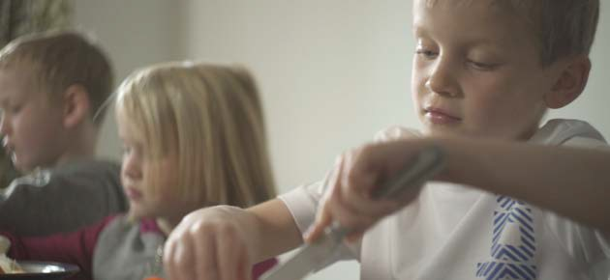

A tasty breakfast overnight oat recipe, making the most of the seasonal rhubarb
Shopping & Ingredients List:
200g rhubarb cut into 4cm pieces 3 tbsp runny honey
120ml orange juice 120g rolled oats
1 tsp cinnamon
250g Fat free Skyr Yogurt 50g toasted flaked almonds

drizzle of honey to serve

Method
- Put rhubarb in a large saucepan with the honey and orange juice and poach on a low heat for 10 mins
- cool and drain liquid into a jug
- Mix the liquid with the oats, cinnamon yogurt, half the almonds and halfb the rhubarb
- Stir to combine and put in the fridge overnight
- Serve the oats with the remaining almonds, rhybarb and a drizzle of honey

Macro info per serving

Protein |  | Carbs |  | Fat |  | Energy  309kcal
14g |  | 43g |  | 9g

Simnel Spelt Pancakes

Breakfast

Serves: 4
Shopping & Ingredients List:

25g powdered oatmeal 25g ground almonds
30g Wholemeal Spelt flour 20g corn flour
4 eggs
splash of semi skimmed milk 60g dried mixed fruit with zest

Pancakes are always a great breakfast solution - this idea came from the traditional Easter Simnel cake recipe - give it a try and see what else you can top your pancakes with

Method
- Mix the oatmeal, almonds, spelt four, corn flour and eggs together to make a batter.
- Add a splash of milk to loosen if needed
- Pour batter into frying pan - greased with oil spray
- Sprinkle a quarter of the dried fruit mix over the top of the pancake as it cooks. The fold in half.
- Once cooked through serve and eat immediately

Macro info per serving

Protein |  | Carbs |  | Fat |  | Energy  230kcal
10g |  | 25g |  | 10g

Celtic inspired Pottage
Serves: 4

My eldest taught me this recipe when they studied Celtic history at school. As such, all my kids were eager to wolf down this highly nutritious creation.
Shopping & Ingredients List:
3 turnips
2 carrots
1 parsnip (total 1lb of veggies in total) 25g butter
60g oats
1 tbs chopped fresh parsley
570ml bone broth or stock (nutrition based on using chicken bone broth)
Whack it in a flask and take a fresh loaf and some mini cheeses and you're set for a Celtic inspired picnic.

Method
- prepare vegetables
- place in saucepan with butter and fry till softened
- add chopped parsley and oats
- add bone broth / stock
- cover and cook slowly for 20-30mins, stirring occasionally

Macro info per serving

Protein |  | Carbs |  | Fat |  | Energy  208kcal
10g |  | 24g |  | 8g

Spring onion bacon battle spears

Lunch

Serves: 1

Inspired by street foods we tasted on a trip to Portugal
Shopping & Ingredients List:

4 x spring onions trimmed
2 x rashers lean bacon
Great for kids who love to graze. Place on platter - or section into a lunch box and allow them to navigate their own spears into their mouths.
Can be eaten cold too.

Method
- - after trimming the ends of the spring onions, wrap a slice of lean bacon (trimmed fat) around two spring onions
- - place on a griddle pan, or under grill
- - Grill - turning occasionally till bacon thoroughly cooked and spring onions are wilted

Macro info per serving

Protein |  | Carbs |  | Fat |  | Energy  127kcal
20g |  | 5g |  | 3g

Finger friendly Spring Rolls

Serves: 2

Ideal finger foods to prepare in advance for lunch boxes or picnics as an alternative to sandwiches
Shopping & Ingredients List:
- tbsp groundnut oil
- gloves garlic finely chopped tsp grated fresh ginger
1 red chilli - deseeded and finely chopped 300g bag of mixed stir fry vegetables
1 tbsp soy sauce
1 tbsp rice wine vinegar
4 sheets filo pastry (approx 15cm x 12cm) 4 pre cooked slices of topside beef (Lidl used in nutrition data) thinly sliced into strips

Method
- Heat a pan / wok over a high heat. Add oil garlic, ginger and chilli.
- Stir fry for half a minute then add the mixed veggies, soy sauce and vinegar and cook for 1 mins
- Add the sliced beef and cook for another minute.
- Spoon the veg over a sieve and allow to cool slightly
- place a spoonful of the mixture at one end of the filo rectangle, centrally. Roll the pastry around the veg until halfway along the filo sheet.
- Fold each side of unfilled pastry into the center, and continue rolling the cylinder.
- repeat with other sheets
- Bake in oven at 200 degrees for 15 minutes. eat hot or cold.

Makes 4 in total - 2 per serving

Macro info per serving
Protein |  | Carbs |  | Fat |  | Energy  244kcal
9g |  | 34g |  | 8g

Spring Green Watercress Quiche
Lunch
Serves 6

Shopping & Ingredients List:

bunches watercress finely chopped 225g shortcrust pastry
350g fat free cottage cheese - sieved 2 eggs and 1 egg whites beaten
- tbsp semi skimmed milk pinch cayenne salt and pepper
1 beaten egg white for sealing pastry
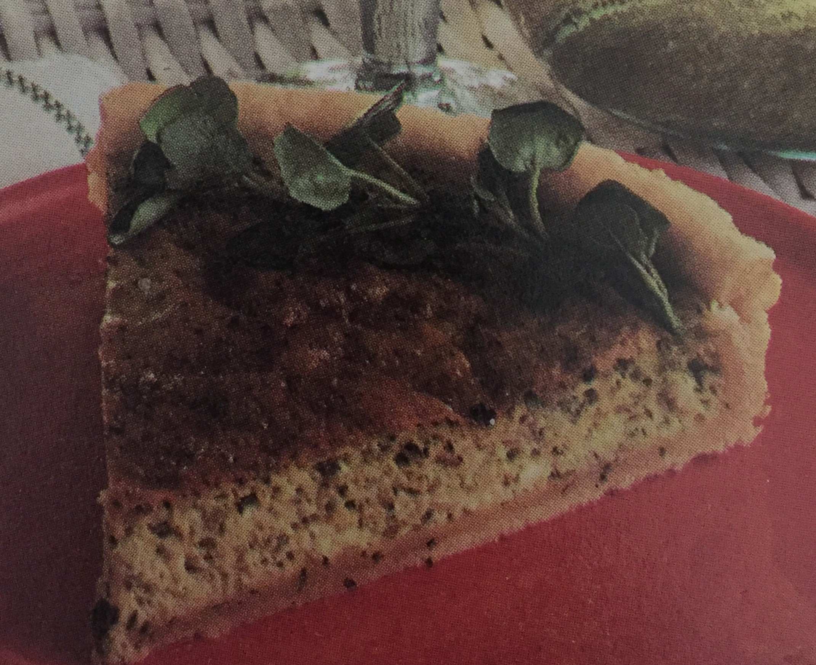
Another pre prepared lunch recipe to equip you for easy finger food packed lunches or picnics, plus a good serving of spring watercress to boost fibre and micro nutrient intake

Method
- Roll out pastry on floured surface and place in lined 23cm flan tin - remember to prick base with fork
- Bake in the oven at 200 degrees for 10 minutes (you can use baking beans to weigh down the center if you have them)
- Brush pastry with beaten egg white and return to oven for 5 mins
- Mix together the cottage cheese, chopped watercress, beaten eggs and milk in a bowl
- Add cayenne, salt and pepper
- Spoon the filling into the cooked pastry case, and spread evenly
- Return to oven and cook for about 45mins or until the filling has set and golden brown on top Can be eaten hot or cold

Macro info per serving
Protein
13g
Carbs
17g
Fat
10g
Energy
210kcal

Cabbage and cucumber egg salad
Lunch

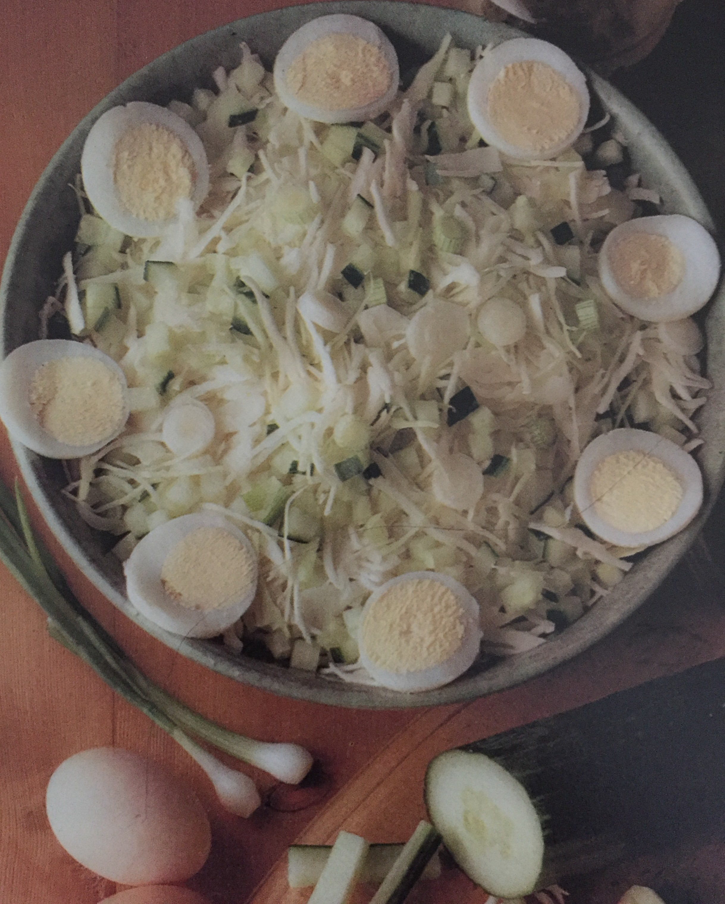
Serves: 4
Shopping & Ingredients List:
500g white cabbage 1/2 cucumber
6 spring onions

Dressing:
5 tbsp olive oil
2 tbsp white wine vinegar 2 tbsp chopped mint leaf 1/4 tsp french mustard

4 hard boiled eggs

Who says salads have to be boring! Embrace the fresh greens of the season and top with a freshly boiled egg!
Method
- Finely shred cabbage and place into salad dish
- Dice the cucumber and toss with the cabbage
- thinly slice spring onions and add, encourage your kids to get involved with tossing the salad!
- halve the boiled eggs, and decorate around the outside of the salad dish.
- mix together dressing ingredients and drizzle over salad ensuring the leaves are evenly coated.

- Enjoy

Macro info per serving
Protein
9g
Carbs
13g
Fat
23g
Energy
295kcal

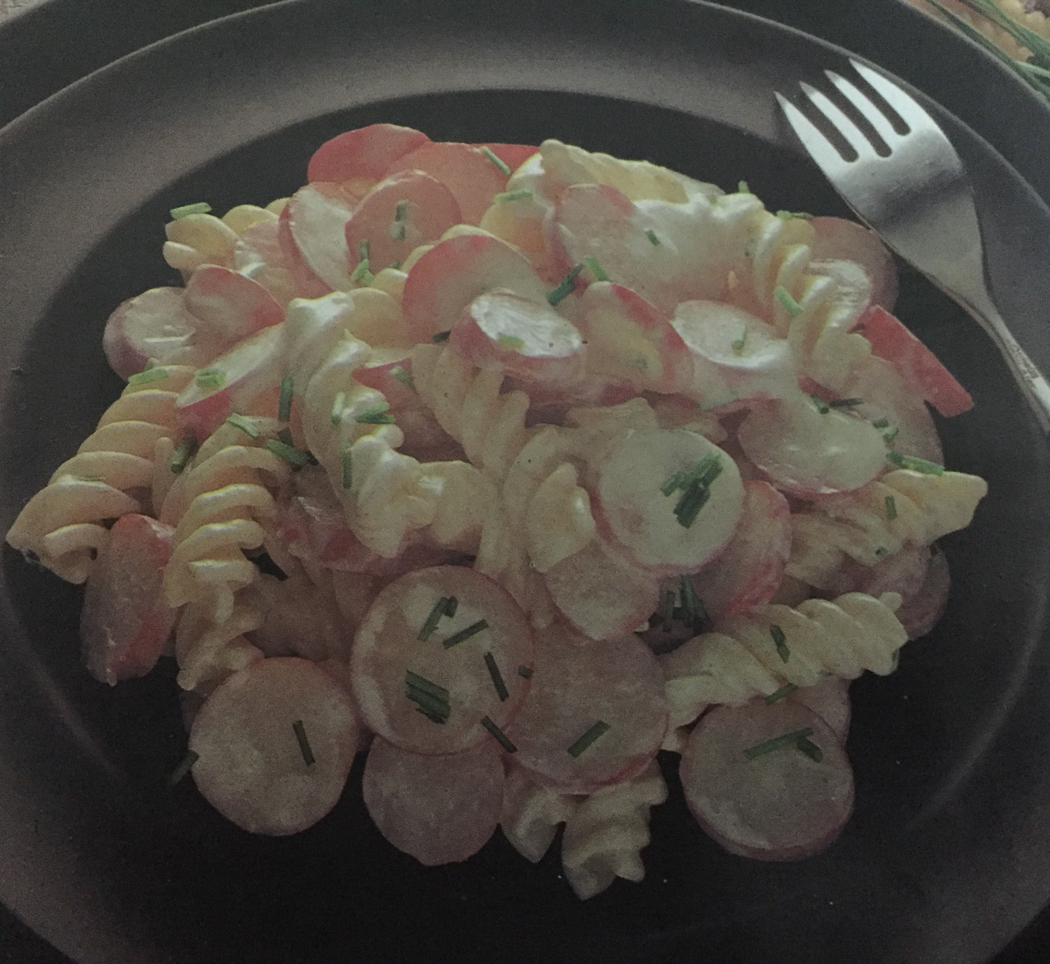
Radish Pasta Salad

Serves: 4

Surprisingly, some children have never seen or tasted a radish. With a peppery taste it can be a love hate relationship - with this recipe you kids can try a seasonal favourite.
Shopping & Ingredients List:
250g radishes 100g pasta spirals salt
- tsp olive oil
- tbsp snipped chives 150ml soured cream pepper

Method
- Cook pasta as per instructions - rinse with cold water to remove excess starch and drain thoroughly
- Slice radishes into 3-4 slices
- Transfer the pasta to a serving dish, and add the radishes, chives, soured cream and season with salt and pepper
- Toss well and serve

Macro info per serving
Protein
4g
Carbs
24g
Fat
7g
Energy
175kcal

Pinwheel sandwiches

Lunch

Serves: 1

Shopping & Ingredients List:

2 medium slices wholemeal bread
1 tbsp Cream cheese with garlic and herbs

Lunchtime wouldn't be lunchtime without a sandwich option. Here's our family spin on the traditional lunchtime favourite, to make a humble sandwich, just a little more appealing...

Method
- Cut off the crusts and roll out the slices of bread with a rolling pin
- Spread the filling over the flattened bread, and roll up length-ways
- Slice into pinwheels and serve

Serve with celery fingers and peanut butter dip 1 x celery stick and 1 x tbsp peanut butter included in macros

Macro info per serving
Protein
9g
Carbs
34g
Fat
8g
Energy
244kcal

Spring Lamb en Croute
Main meal serves 8
Shopping & Ingredients List:
150g chick pea flour 50g butter

750g shoulder of lamb 4 garlic cloves peeled 2 tbsp olive oil
100g button mushrooms chopped finely 20g sun-dried tomatoes chopped finely
Handful of fresh chopped parsley

Lamb is the meat of the season, but we don't need to stick to a traditional roast with mint sauce - try this weekday alternative with your family.

Method
- place the flour in a bowl and cut in the butter
- crumble with fingers until like fine sand then add 406 tablespoons water to make a soft dough. Cover and place in fridge to chill
- Cut slits in the lamb and push in the hole garlic cloves in each slit
- Cover the lamb with foil and bake at 180 degrees for 40 minutes. Remove and allow to partially cool
- Heat the oil and sweat the mushrooms with the sundried tomatoes, cover and leave for 5-10 minutes. Then add the parsley
- Spread the mushroom mixture over the top of the lamb.
- Roll out the dough and use the pastry to cover the lamb, tucking in around the bottom of the joint 8 Return to oven and cook for a further 20-30 minutes until the pastry is crisp and lightly browned.

Serve with fresh seasonal vegetables

Macro info per serving
Protein
26g
Carbs
10g
Fat
21g
Energy
333kcal

Stir Fry Chicken and Prawns

Main Meal

Serves: 4
Shopping & Ingredients List:
275g Chicken Breast, in strips 125g peeled, cooked Prawns
3 Celery Sticks, finely chopped 1 Onion, finely sliced
1-2 Peppers, sliced
2 Garlic Cloves, crushed 2 tbsp Olive Oil
2 tbsp Lemon Juice
Method
- Heat oil in wok. Stir in celery, peppers & onion. Cover & cook over gentle het for 3 mins.
- Stir in garlic, chicken, prawns. Cover & cook for 8-10 mins.
- Add lemon juice, stir & serve.

Macro info per serving
Protein
25g
Carbs
8.2g
Fat
7.7g
Energy
203kcal

Lamb Hotpot

Main Meal

Serves: 2

If you have a slow cooker this is a simple way to have a hearty warming meal, ready for when you get in. If your kids are teenagers who come home from school by themselves, they'll have a tasty and nutritious meal to dig into when they get home. Increase the ingredients for number of portions.

Shopping and Ingredients list:
125 g of lean diced lamb
One lamb stock cube with enough water to cover the meat
Half a teaspoon of dried thyme Half a teaspoon dried rosemary 1 teaspoon of salt/pepper
One medium chopped carrot Two chopped celery sticks
Method
You can either whack all the ingredients in a slow cooker in the morning meaning the meal will be ready when you get in the evening or you can place all the ingredients in a pan and bring to boil then on a very low heat and simmer for 45 to 50 minutes until the meat is tender. Serve with any choice of green vegetables.

Macro info per serving

Protein |  | Carbs |  | Fat |  | Energy  212kcal
19g |  | 14g |  | 12g

Ginger Salmon skewers

Main Meal

Serves: 4
Shopping & Ingredients List:
500g Salmon Fillets, cut into chunks

Marinade
50g fresh Root Ginger, cut into small chunks 1 tbsp Olive Oil
1 Lemon, Juice only 1 Chilli, finely diced
Oily fish is incredibly beneficial for growing kids. We should aim for at least 2 portions per week. Remember to remover the skewers before serving to younger children

Method
- To make marinade, first press this ginger, through a garlic press & capture the juice into a bowl. Mix with remaining ingredients.
- Place salmon in a non-metallic dish, pour over marinade & chill in fridge for 30 mins.
- Soak wooden skewers in cold water, or use metal ones. Thread on salmon & cook on bbq, or under a hot grill, for 3-4 mins on each side. serve with salad.

Macro info per serving
Protein
25g
Carbs
1g
Fat
9g
Energy
185kcal

Baked Spinach Omelette
Main Meal
Serves: 4

A meat free simple dish to help get them to eat their greens. My daughter calls this the wicked witch omelette. Add cheese, or bacon for a fuller meal,or serve with new potatoes
Shopping & Ingredients List:
750g fresh spinach 25g butter
1 onion finely chopped
4 whole eggs 4 egg whites beaten salt & pepper to season

Method
- Place spinach in large saucepan after rinsing. cook on low heat for 3-5 mins shaking pan continuously
- Melt the butter in frying pan add onion and fry for 5 mins
- Drain spinach and roughly chop, add to frying pan with onions and fry a little to coat in butter
- Remove from heat
- Add half of beaten eggs to a shallow oven proof dish - spread the chopped spinach evenly over the top and then pour the remaining egg mix over
- bake in oven for 15 mins Can be served hot or cold

Macro info per serving
Protein
15g
Carbs
6g
Fat
14g
Energy
110kcal

Orange Roasted Chicken

Main Meal

Serves: 8
Shopping & Ingredients List:
400g Baby Carrots, halved lengthways 4 Chicken Breasts, skinned & boned 200g Spring Greens, chopped
juice of 2 Oranges 150ml Chicken Stock 4-6 Thyme Sprigs

A twist on a traditional roast chicken to add some spring freshness and zest. Serve with seasonal veg, and roast potatoes

Method
- Preheat oven to 200c (180 fan), 400f, gas mark 6. Put carrots, thyme, stock in large roasting tray. Cover with foil & bake for 10 mins.
- Remove foil. Add chicken breasts, pour over orange juice & return uncovered to the oven for 30 mins.
- Meanwhile steam spring greens until just cooked & serve alongside the roast chicken.

Macro info per serving
Protein
20g
Carbs
8g
Fat
1g
Energy
121kcal

Potato Spring Surprise

Main Meal

Serves: 4
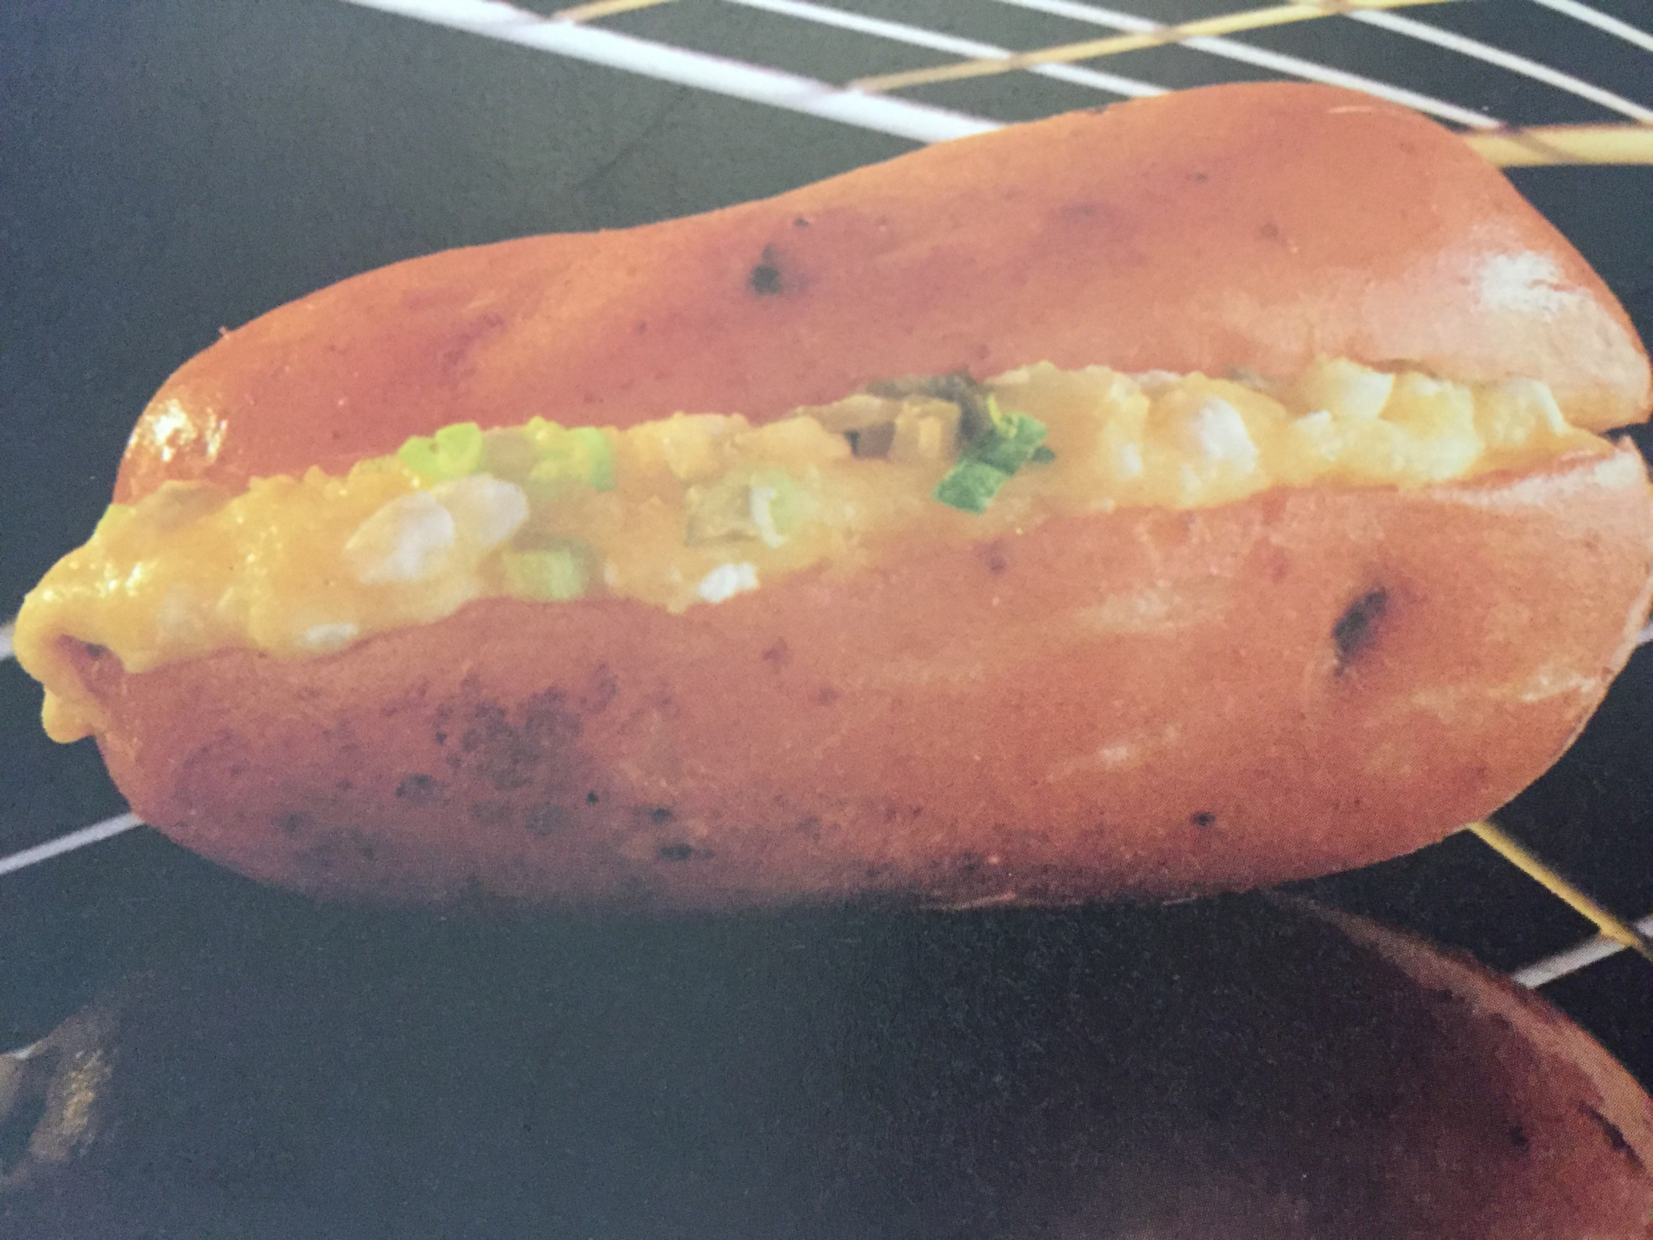

Shopping & Ingredients List:
4 baking potatoes
150g fat free cottage cheese 150g grated cheese
4 spring onions finely chopped 2 gherkins finely chopped olive oil for greasing

salt and pepper to season
Baked potatoes are a great way to increase iron and fibre - hears our family favourite with a spring twist

Method

- Microwave baking potatoes for 5-10 minutes (depending on size) to partially cook
- Rub olive oil and salt into the skin, then chop in half.
- Scrape out the partially cooked potato flesh and mash together with the cottage cheese and spring onions
- Repil each of the 8 potato halves with the mash and top with gherkins and grated cheese.
- Place in an oven proof dish and cook at 180 for 30-45 minutes (depending on size) until skins are crispy

Serve immediatly - dont burn your mouth!

Macro info per serving
Protein
11.2g
Carbs
59.2g
Fat
4.2g
Energy
320kcal

Shopping & Ingredients List:
1 small Cauliflower
1 tsp dried Herbs, own choice
Salt & Pepper to own taste

Macro info per serving
Method
- Chop cauliflower into small bite-size pieces. Place in microwave safe bowl. Sprinkle with a little water. Cook on high for 8-10 mins.
- Using a fork mash down the cauliflower a little & cook on high for 8-10 mins.
- Using a masher, mash cauliflower to smooth in own juices. Add generous amounts of seasoning & herbs. Stir in & microwave for 2-3 mins.
Easy Cauliflower Mash

Side

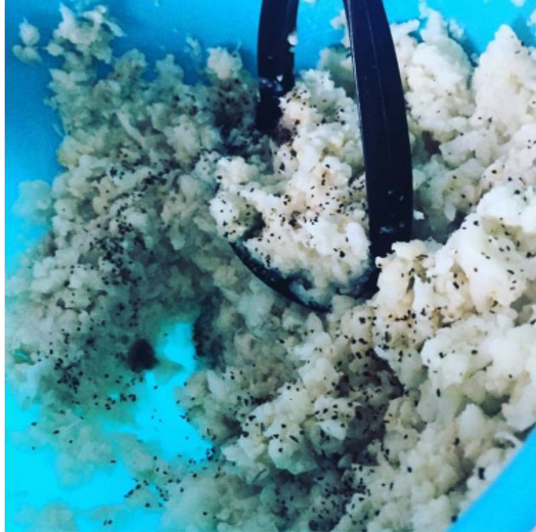
Serves: 1

Protein |  | Carbs |  | Fat |  | Energy
5g |  | 13g |  | 1g |  | 81kcal

Lemony broccoli
Side
Serves: 1

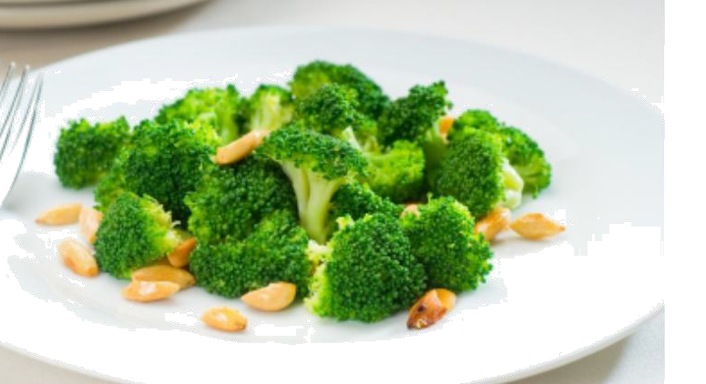
Shopping & Ingredients List:
100g Broccoli
2 tbsp Lemon Juice 20g Toasted Almonds pinch Chilli Flakes

Method
- Sprinkle broccoli with half the lemon juice & sprinkle over chilli flakes. Steam for 5+ minutes depending on your taste.
- Serve with remaining lemon juice sprinkled over & almonds scattered.

Macro info per serving
Protein
7g
Carbs
13g
Fat
11g
Energy
179kcal

Cucumber Salad
Shopping & Ingredients List:
1 Cucumber, diced
1 Lemon, flesh diced & juice
½ tbsp White Wine Vinegar handful Mint Leaves, chopped handful Basil Leaves, chopped

Serves: 4

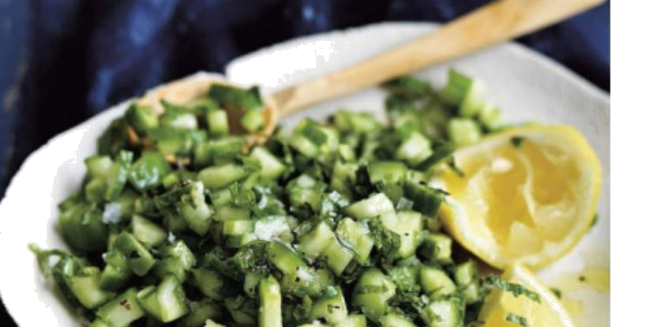

Method
- In a small bowl whisk together the white wine vinegar, juice & herbs.
- In a another bowl toss the cucumber with the lemon flesh & then mix through the dressing.

Macro info per serving

Protein |  | Carbs |  | Fat |  | Energy
0.7g |  | 5.5g |  | 0.2g |  | 27kcal

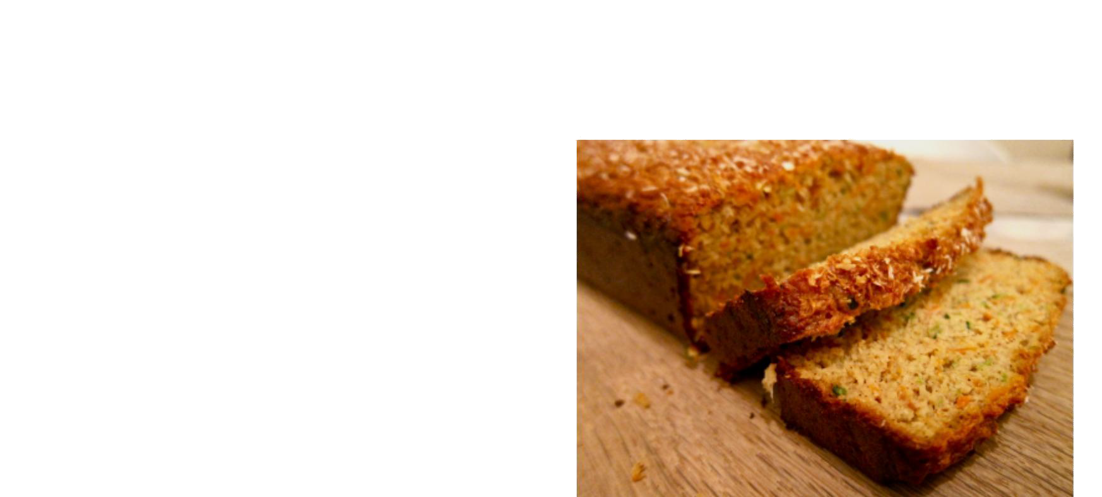
Courgette Cake
Snack
Serves: 4
Shopping & Ingredients List:
1 Courgette, grated
1 Egg
1 Vanilla Pod, seeds scrapped 2 tsp Ground Ginger
½ tsp Nutmeg 100ml Coconut Milk 50g Coconut Flour 1 tsp Baking Powder
50g Applesauce, unsweetened
50g Vanilla Protein Powder
Method
- Preheat oven to 180c (160 fan), 350f, Gas Mark 4. Grease small loaf tin, or use a silicon one.
- In a bowl mix together the flour, protein powder, spices & baking powder.
- In a separate bowl whisk together applesauce, egg, milk, vanilla, courgette. Slowly mix this into the flour mix. Pour cake batter into the loaf tin and bake for 30mins. If the top of the loaf appears to be ‘catching’ cover with foil.
- Allow cake to cool a little. Remove from loaf tin.

Macro info per serving
Protein
12.7g
Carbs
10.7g
Fat
4.2g
Energy
131.4kcal

The information provided in this book should not be relied on to suggest a course of treatment for a particular individual.

It should not be used in place of a visit to, consultation with or the advice of a doctor, or another qualified healthcare provider.

Discretion and common sense should be used.

Information in this book does not cover all/any aspects of medical health issues, ailments, allergies, or physical conditions or their treatment.

Should you have any health care related questions, call or see your doctor or another health care provider promptly. You should never disregard medical advice or delay in seeking it because of something you have read in thisbook.

Nutritional values in the meal planner / recipes are taken from third-party sources; due to differences in sizes, brands and localisation, nutritionalvalues may differ.

Always double check nutritional information and use common sense.

The book is provided without any warranty, and the use of the book is solely at your own risk.

Before relying on the material in this book, users should independently verify the accuracy, the completeness, and the relevance for their purposes, obtaining professional advice when appropriate or applicable as the material in the book may include opinions, recommendations, or content from third parties, which may not reflect your views.

By accepting and using the book and any information contained in the book you understand and acknowledge that everyone that has contributed or prepared this book disclaims any liability to you, and all such persons are not liable for losses or damages which may result through the use of the information, products, and service presented in this book or any other materials or information relating to the book.

The statements in this book have not been evaluated by any external authority. The recommendations are not intended to treat or cure any disease or condition.

