www.e-hospital.co.uk

Author: Jennifer Bulcock www.jenniferbulcock.com

Publication Date: December 2016

The Children’s e-Hospital

Winter Diet Plan

Blueberry Coconut Oatmeal
Shopping & Ingredients List:

600ml Almond milk 200ml coconut milk 2 tsp coconut sugar 150g rolled oats 150g dried cherries 150g blueberries

Breakfast

Serves:4

A filling and tasty breakfast. Which will provide a great start to the day. Try topping with other fruits for some variety, such as seasonal berries, pears, plums dates and apricots

Method
- Mix all almond milk, coconut milk & coconut sugar in a pan, warm over moderate heat until bubbling
- Add oats and stir well, simmer stirring frequently for 3-4 mins
- add cherries and blueberries and divide between 4 serving bowls

Protein |  | Carbs |  | Fat |  | Energy  224kcal
5g |  | 42g |  | 4g

Chickpea pancakes

Breakfast

Serves: 4
Shopping & Ingredients List:

100g gram flour
Half sachet fast acting yeast (4g)
1 tsp half spoon (sugar/ sweetener) 1 x medium egg
half tsp baking powder

Makes 12 pancakes - 4 per serving

A great breakfast option adding in chickpeas, which are high in fiber. This can be prepped the night before, meaning an easy morning with a nutritious breakfast to start them on their day.

Method
- Night before - put flour sugar and yeast in a mixing bowl.
- add egg and 100ml water and whisk until smooth
- cover with clingfilm and refrigerate overnight
- Before cooking add baking powder and leave for 5 mins
- Use oil cooking spray in frying pan - once hot put 4 heaped dessert-spoons (one for each pancake) into the pan - once risen, flip and serve immediately.

You could top with a drizzle of honey, or lemon and a sprinkle of half-spoon sugar/sweetener.

For a savory option try topping with balsamic vinegar

Protein |  | Carbs |  | Fat |  | Energy  110kcal
8g |  | 15g |  | 2g

Welsh baked eggs

Breakfast

Serves: 4
Shopping & Ingredients List:

4 eggs
60ml single (light) cream 4 small leeks

A fun breakfast in our house - we made up a song about the "Lady with the Leeks"
Food and mealtimes can be more enjoyable for children if we embellish the moment with songs and stories.

Method
- Use oil spray in a pan, add the chopped leeks and cook for 1 minute.
- reduce heat and cover for 5 mins to soften leeks (this could be done the night before if easier).
- Spoon into 4 ramekin dishes, and break an egg over the top of each.
- Add a spoonful of cream and season
- Place in the oven and cook until eggs are to yours (or your kids) liking

Try different veggie options, such as courgette, asparagus, spinach, or even mushrooms for a tasty savory breakfast

Protein |  | Carbs |  | Fat |  | Energy  173kcal
9g |  | 14g |  | 9g

Winter warmer rice pudding

Breakfast

Serves: 4
Shopping & Ingredients List:
100g pudding rice
600ml semi skimmed milk small orange zest
2 tbsp honey 12g butter
4 large egg yolks beaten 100ml single cream
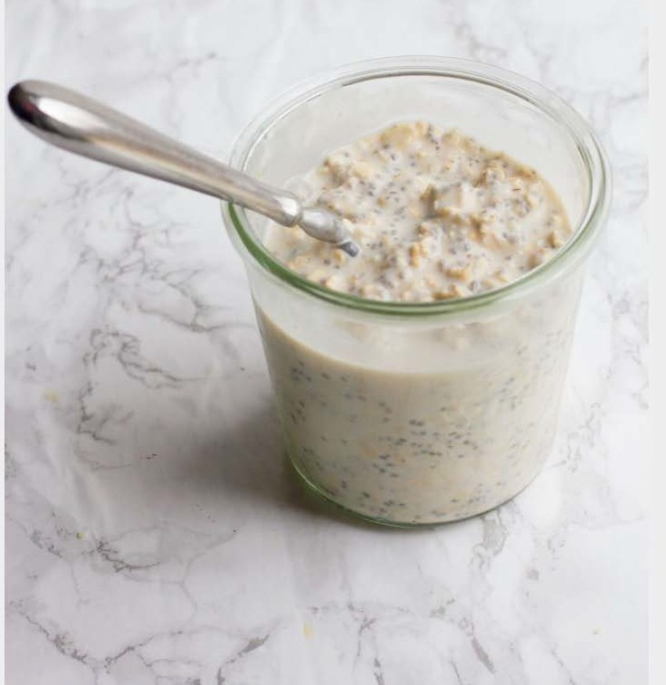

Snuggle up on a dark winters morning and enjoy a luxurious warming breakfast - full of energy to see the kids through until lunchtime.

Method
- Use a spray oil to grease an deep oven proof dish and heat oven to 180c
- Place rice in a pan, add the milk, orange zest and slowly bring to boil.
- Cook for 15 mins until rice is tender.
- Turn off the heat under the pan and mix in the honey and butter.
- Leave to cool for 5 mins then add the thoroughly beaten egg yolks, followed by the cream
- Pour into the oven dish and place into the oven for about 30 minutes, stirring thoroughly every 10 mins.

This can be served straight from the oven - or prepped in advance. You could even make a big batch and free, ready to microwave for a quick morning breakfast boost.

Protein |  | Carbs |  | Fat |  | Energy  305kcal
10g |  | 37g |  | 13g

Spicy asparagus soldiers and dippy eggs

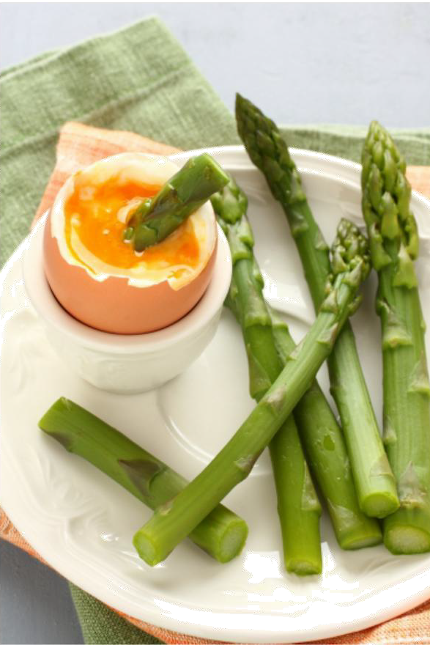
Breakfast

Serves: 1
Shopping & Ingredients List:
7g Almond Flour
½ tbsp Olive Oil 1 large Egg
4 Asparagus Spears
½ tsp Paprika
½ tsp Chilli

Asparagus goes incredibly well with a nice gooey egg, and is a great way to get a portion of veggies in at breakfast – plus my kids love having asparagus sword fights at the breakfast table.
Method
- Heat oil in large non-stick frying pan. Add the almond flour & fry until crisp & brown.
Season with spices. Leave to cool.
- Cook asparagus in large pan of boiling salted water for 3 mins.
- At same time boil eggs for 3-4 mins.
- Drain the asparagus. Place on plate, sprinkle over the ‘breadcrumbs’. Place egg in egg cup
- Use asparagus to dip into soft boiled egg.

*If the kids are averse to the green swords, don't despair, keep serving them, but have the option of whole meal toast too. If you stop offering certain foods, they may struggle to develop the skills to explore new tastes.
It can take up to 16 attempts at tasting a new food before we start to develop a liking to a new taste.

Protein |  | Carbs |  | Fat |  | Energy  204kcal
10g |  | 5g |  | 16g

Microwave Ginger mug cake

Breakfast

Serves: 1

No excuse easy breakfast that will be eaten as quickly as its made but will provide a good balance of macro- nutrients to set the kids up to a good start
Shopping & Ingredients List:
1 large egg
10g whole-nut peanut butter Half tsp baking powder
30g whole meal spelt flour 2 tsp honey
1 tsp ground ginger

Method
- Mix all ingredients together to form a smooth paste
- Pop in the microwave for 45-60 seconds
- serve topped with seasonal berries

Protein |  | Carbs |  | Fat |  | Energy  356kcal
14g |  | 48g |  | 12g

Date energy breakfast bombs

Breakfast

Serves: 4
Shopping & Ingredients List:

Makes approx 20 balls

110g powdered oats 55g ground almonds
225g tinned prunes (in juice) 55g ground flaxseed

Start the day with an explosion of energy with these simple energy bombs. Full of goodness, and can be prepped in batches for an easy on the go, school run breakfast

Method
- Place all ingredients into a food processor and mix together.
- This should make a tick consistency that can be rolled into individual energy balls and placed in the refrigerator to set. If the mixture is too wet, add more powdered oats.

These are simple to make in advance and provide a simple quick breakfast solution that can be eaten on the way to school if needed.

Protein |  | Carbs |  | Fat |  | Energy  292kcal
10g |  | 27g |  | 16g

Creamy pumpkin Soup
Serves: 4

No need to let the pumpkins go to waste, you can usually grab a bargain after the Halloween period too. Invite the kids to the kitchen and allow them to be involved in creating this winter warming soup.
Shopping & Ingredients List:
1.25kg diced pumpkin 1tbsp olive oil
2 shallots diced
2 cloves garlic, minced 650ml veg stock
250ml light coconut milk
75g unsweetened coconut milk yogurt chopped chives to garnish

Method
- place pumpkin in backing tray, drizzle with oil and pop in oven at 180c for 35-40 mins
- fry shallots and garlic in pan with oil spray
- Once pumpkin is cooked - add to the pan with shallots. Add stock & coconut milk whilst stirring well
- simmer for 5 mins then using a hand blender, blend until smooth
- ladle into bowls and serve with a swirl of coconut milk yogurt and garnish with chives.

Fresh crusty wholemeal bread would be a lovely wintry accompaniment to this warming soup. Or add in some shredded chicken to make it more filling, higher protein meal.

Could also be popped into a flask as a warming lunch during a frosty winters walk.

Protein |  | Carbs |  | Fat |  | Energy  128kcal
2g |  | 12g |  | 8g

Cucumber boats

Lunch

Serves: 1

Great for kids who love to graze. Place on platter - or section into a lunch box and allow them to navigate their own boats, into their mouths.....
Shopping & Ingredients List:

1/2 cucumber
2 hard boiled eggs
1 tbsp low fat mayonnaise

Method
1 - Chop the cucumber in half and scrape out the seeds 2 - Chop into 4 pieces to make the base of the boats
3 - mash up the boiled eggs with the mayonnaise, then spoon the mixture into the four cucumber boats

Protein |  | Carbs |  | Fat |  | Energy  217kcal
15g |  | 10g |  | 13g

Carrot & Ginger Soup

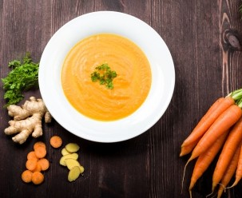
Serves: 2

Soups are a staple during this time of year, and can be popped into a flask for a warming winter picnic pick-me-up
Shopping & Ingredients List: 1 tsp Olive Oil
1 Onion, diced
1 Star Anise
1 tsp Root Ginger, grated 100g Carrots, grated
½ Cinnamon Stick 600ml Vegetable Stock
Salt & Pepper to own taste Cumin Seeds & Coriander, garnish

Method
- Gently fry the onion in a non-stick pan with the oil, star anise & ginger.
- Add carrots, cinnamon, stock & simmer for 20 mins.
- Remove the star anise & cinnamon. Blend the soup until smooth & serve with garnish of cumin seeds & coriander.

Serve with crusty wholemeal bread, you could even add some shredded chicken to increase the protein content and provide a more filling meal for older children and adults.

Protein |  | Carbs |  | Fat |  | Energy  82kcal
1.5g |  | 10g |  | 4g

Thick Bean Soup
Lunch
Serves 4
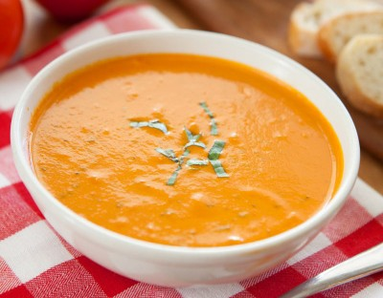

Another simple soup recipe but high in plant based protein, adding in fibre and nutrients.

Shopping & Ingredients List:
2x400g tin Butter Beans, drained & rinsed
60g Sun Dried Tomato Puree
900ml Vegetable Stock 3 tbsp Pesto

Method
- Put stock in saucepan with the butter beans. bring to the boil, reduce heat, stir in tomato puree & pesto. Simmer for 5 mins.
- Blend the soup to smooth & return soup to the saucepan.
- Heat gently, stirring frequently for a further 5 mins before serving.

Protein  10.5g |  | Carbs M  31.2g |  | 7.2g |  | Energy  323kcal

Beetroot and Apple Soup
Lunch

Serves: 4
Shopping & Ingredients List:
1 kg raw Beetroot
1 large Onion, chopped 200ml Apple Juice
1 small Apple, chopped 750ml Vegetable Stock 1 tbsp Coconut Oil
4 Garlic Cloves, crushed
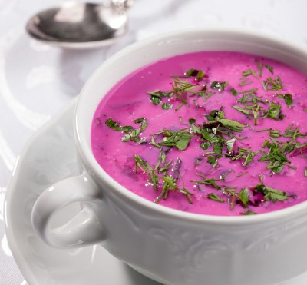

Who says soups should be boring in colour!
Tastes great when accompanied with a toasted wholemeal pitta bread.

Method
- Heat oil in large pan, add onion & garlic, cover & cook over low heat for 10 mins.
- Add beetroot & apple, cover & cook for 10 mins.
- Add stock, cover & simmer for 30 mins. Leave to cool slightly & liquidize in a blender until smooth. If necessary reheat before serving.

Macro info per serving
Protein |  | Carbs |  | Fat |  | Energy  117kcal
3g |  | 20g |  | 3g

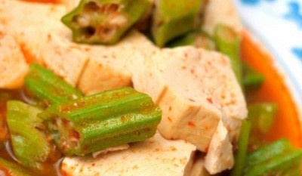
New Year Tofu Special
Serves: 4
Shopping & Ingredients List:
2 tbsp Olive Oil
100g Almonds, roughly chopped 200g Okra
200g Oyster Mushrooms, roughly chopped 200g firm Tofu, drained & diced
2 Garlic Cloves, crushed
2 tbsp Miso paste
Tofu isn't just for vegetarians. It is a great source of protein and can be easily used in a variety of dishes for a healthy meat alternative

Method
- In a large pan warm 1 tbsp of olive oil & stir in the okra. Turn heat to medium-high & sauté for 2-3 mins until okra starts to brown. Put okra in a bowl & set aside.
- Add remaining olive oil to the pan & stir in both the mushrooms & the tofu. Keep stirring & frying until they start to brown. Add the garlic & cook for a further 30 seconds.
- Return the okra to the pan & add the miso paste. Combine well & add the almonds. Stir for 30 seconds more.

Macro info per serving

Protein |  | Carbs |  | Fat |  | Energy  359.5kcal
23.5g |  | 13.5g |  | 23.5g

Toasted 'snack'wiches

Lunch

Serves: 1

Shopping & Ingredients List:

2 medium slices wholemeal bread
1 tbsp Cream cheese with garlic and herbs

Lunchtime wouldn't be lunchtime without a sandwich option. Here's our family spin on the traditional lunchtime favourite, to make a humble sandwich, just a little more appealing...

Method
- cover 1 slice with the garlic and herb cream cheese spread
- place 2nd slice on top to seal the sandwich
- Slice into 3 fingers and place a cocktail stick through each one
- Place strips on a sheet of foil and toast on each side

Serve with celery fingers and peanut butter to dip 1 x celery stick and 1 x tbsp peanut butter included in macros

Macro info per serving
Protein
14g
Carbs
35g
Fat
14g
Energy
322kcal

Creamy Asparagus Curry
Main meal serves 4
Shopping & Ingredients List:

2 tbsp avocado oil 2 tbsp curry paste
450g potatoes - peeled & diced 600ml unsweetened coconut milk 275g trimmed asparagus
75g unsalted peanuts 1 tbsp fish sauce
1 tbsp white wine vinegar coriander leaves to serve

Asparagus can be an acquired taste. If you find the dippy asparagus soldiers at breakfast are a hit, you may want to give this yummy curry a go with your little ones

Method
- Heat the oil in a pan, then add the curry paste
- add the potatoes stirr well and fry for a minute
- cover with coconut milk and a cup of water.
- Simmer for 10 mins until potatoes are tender
- Add asparagus, peanuts, fish sauce and vinegar
- Cook for a further 3 mins
- ladle into bowls and serve with coriander garnish

Protein |  | Carbs |  | Fat |  | Energy  287kcal
9g |  | 20g |  | 19g

Pumpkin Curry

Main Meal

Serves: 4

Another recipe to make the most of the post autumn bargains. A warming winter curry packed with energy and fibre
Shopping & Ingredients List:
1 onion roughly chopped
4 crushed garlic clove
2 tsp ground coriander 2tsp madras curry powder 1 tbsp coconut oil
1 tsp cumin seeds 900g diced pumpkin
150g brown basmati rice 500ml vegetable stock

Method

Blitz together the onion garlic ground coriander, curry powder and a splash of warm water in a food processor
- Heat oil in pan over medium heat, add cumin seeds and fry for 30 seconds
- Add the paste from food processor and fry for 2 mins 4.Pour in vegetable stock, add the pumpkin and rice.
5.bring to boil then cover and simmer for approx 15 minutes until rice & pumpkin are tender 6.Fluff with fork and serve - can be topped with a dollop of creme fraiche

Protein |  | Carbs |  | Fat |  | Energy  193kcal
5g |  | 32g |  | 5g

Lamb Hotpot
Main Meal
Serves: 2

Shopping and Ingredients list:
Method
You can either whack all the ingredients in a slow cooker in the morning meaning the meal will be ready when you get in the evening or you can place all the ingredients in a pan and bring to boil then on a very low heat and simmer for 45 to 50 minutes until the meat is tender. Serve with any choice of green vegetables.
125 g of lean diced lamb
One lamb stock cube with enough water to cover the meat
Half a teaspoon of dried thyme Half a teaspoon dried rosemary 1 teaspoon of salt/pepper
One medium chopped carrot Two chopped celery sticks

If you have a slow cooker this is a simple way to have a hearty warming meal, ready for when you get in. If your kids are teenagers who come home from school by themselves, they'll have a tasty and nutritious meal to dig into when they get home. Increase the ingredients for number of portions.

Protein |  | Carbs |  | Fat |  | Energy  212kcal
19g |  | 14g |  | 12g

Chicken Korma

Main Meal

Serves: 6

Shopping & Ingredients List:
4 chicken breast skinned and chopped 225ml low fat plain yogurt
2.5cm root ginger finely chopped 4 crushed garlic cloves
2 large onions
2 red chilies
1 tsp ground masala 1/2 tsp turmeric
100g creamed coconut 2 tbsp ground almonds

A mild curry option for a sensitive palate. A great way to introduce kids to curry. Can be combined with rice or *cauliflower rice (see side recipes)

Method
- Marinate the chicken overnight in the yogurt mixed with garlic and ginger
- spray pan with oil spray and fry 1 onion over medium heat
- Put other chopped onion in food processor with chilies, coriander, garam masala and turmeric and blend
- Once blended, fry the paste over medium heat, then add chicken and yogurt mixture. Once browned, add the creamed coconut and ground almonds.
- After 20 mins on a medium heat, add the previous cooked onion, and if needed a little water to thin the sauce.

Protein |  | Carbs |  | Fat |  | Energy  183kcal
20g |  | 10g |  | 9g

Chilli Con Carne
Main Meal
Serves: 6

A simple family meal that everyone can enjoy together. Serve with rice, cauliflower rice (see sides) or simply whack it in a baked potato.
Shopping & Ingredients List:
Oil spray
1 onion finely chopped 6 garlic cloves crushed 1 tsp ground cumin
1 tsp chilli powder 450g lean steak mince
440g tinned chopped tomatoes 3 tbsp tomato puree
1 red pepper diced
1 green pepper diced 1/2 pint water
400g tinned kidney beans drained and rinsed

Method
- Fry onion and garlic in oil spray
- Once browned, add the cumin and chilli powder.
- Add mince and brown
- Add tinned tomatoes and tomato puree
- Bring to simmer and add the peppers, chilies and 1/2 pint of water
- Leave on low heat to simmer for 45 mins, then add tinned kidney beans and simmer for a further 10 mins

Macro info per serving
Protein |  | Carbs |  | fat |  | Energy  201kcal
18g |  | 12g |  | 9g

Super Salmon & Lentils

Main Meal

Shopping & Ingredients List: | Regular intake of oily fish is vital for optimal development in children. Here’s a tasty recipe both adults and kids will enjoy together | Serves: 8
4 tbsp. olive oil
2 garlic cloves, minced
2 tsp. ginger, minced
1 long red chilli,
seeds removed and finely
chopped
1 medium white onion
½tsp. ground coriander
½tsp. ground cumin
200g tinned Puy lentils, rinsed
and drained
2.5 large ripe plum tomatoes,
finely chopped
400ml vegetable stock
For the Salmon:
800g salmon
4 tbsp. olive oil
100g beetroot, cooked
100g mixed salad leaves
Handful of parsley to garnish
Method
- Preheat the oven to Gas Mark or 200°C. Heat the vegetable oil in a large frying pan and fry the garlic, ginger, chilli and onion on a medium heat for 3-4 minutes.
- Then, mix in the ground coriander and ground cumin. Throw in the Puy lentils, tomatoes and vegetable stock. Bring the mixture to the boil, then turn down the heat and simmer for 5 minutes.
- Heat a non-stick frying pan on a high heat. Pour in the olive oil and cook the salmon, skin side up, in the frying pan for 5 minutes. Then, transfer the salmon onto a baking tray and roast in the preheated oven for 6-8 minutes.
- Remove from the oven and take off the skin before serving. Once the salmon is cooked, plate up by popping pop some lentils in a large bowl, and top with the salmon, some chopped beetroot and some mixed greens
- Garnish with some fresh parsley.

Macro info per serving

Protein |  | Carbs |  | Fat |  | Energy  298kcal
23g |  | 11g |  | 18g

Meat Free Winter Stew
Main Meal
Serves: 4

Shopping & Ingredients List:
- large Onion, chopped 2 large Carrots, chopped
- large Celery Sticks, chopped 500g Butternut Squash, cubed 1 Turnip, cubed
300g Sweet Potato, cubed
400g tin Chickpeas, drained & rinsed 3 Garlic Cloves, crushed
- tbsp Ginger, grated 2 tbsp Ground Cumin
1½ tbsp Sweet Paprika 2 tbsp Ground Coriander 2cm Cinnamon Stick
- pinches Saffron 800ml Vegetable Stock
Salt & Pepper to own taste

Method
- Using a large deep saucepan, add the onion, carrots, celery, & gently saute them in 1-2 tbsp water for 10 mins.
- Next add garlic, ginger, sweet paprika, cumin, coriander, cinnamon stick & cook for 3 mins. You may need to add more tbsp of water to prevent sticking.
- Add the vegetable stock, butternut squash, turnip, sweet potato & chickpeas. Bring to the boil. Reduce to simmer & cook for 25 mins.
- Soak saffron in cup of warm water & add to the stew. Season with salt & pepper before serving.

Macro info per serving
Protein
11.2g
Carbs
59.2g
Fat
4.2g
Energy
320kcal

Broccoli, Cauliflower & Carrot Salad
Side
Serves: 4
Shopping & Ingredients List:
- small Cauliflower, in florets 225g Broccoli, in florets
- Carrots, sliced
- tbsp Chopped Almonds

Dressing
2 tbsp Olive Oil
2 tbsp Red Wine Vinegar
1 tsp Ground Cumin

Method
- Blanch the cauliflower, broccoli & carrots separately in boiling water, allowing 10 mins for cauliflower & 5 mins each for broccoli & carrots. Drain well & refresh in ice cold water.
- Heat non-stick frying pan, add the almonds & fry for 3-4 mins until golden.
- Combine the dressing ingredients. Serve the vegetables at room temperature tossed in the dressing & scatter over the almonds.

Cauliflower Rice
Side
Serves: 4
Shopping & Ingredients List:
- large Cauliflower, grated 3 Onion, peeled & sliced
- tbsp Coconut Oil
1 tbsp Spices own choice

Method
- Melt oil in wok. Add spice & fry over low heat for 1-2 mins to release flavours & aromas.
- Add onion & fry until soft about 4 mins.
- Add grated cauliflower. Stirring constantly fry for 2-3 mins until warmed through & flavours have mixed in. Serve immediately.

Carrot & Sweet Potato Mash
Serves: 4
Shopping & Ingredients List:
500g Carrots, chopped
500g Sweet Potatoes, chopped 3 Garlic Cloves, bashed
1 tsp Cumin Seeds, toasted
25g Butter

Method
- To toast seeds, cook in non-stick frying pan, over a low heat for 1-2 mins.
- Put the carrots, sweet potatoes & garlic in a large pan of salted water, bring to the boil, cook for 12 mins.
- Add cumin seeds, butter & seasoning, roughly mash, serve immediately.

Macro info per serving

Protein |  | Carbs |  | Fat |  | Energy
3g |  | 37g |  | 6g |  | 206kcal

Crunchy Brussels sprouts

Side

Serves: 6
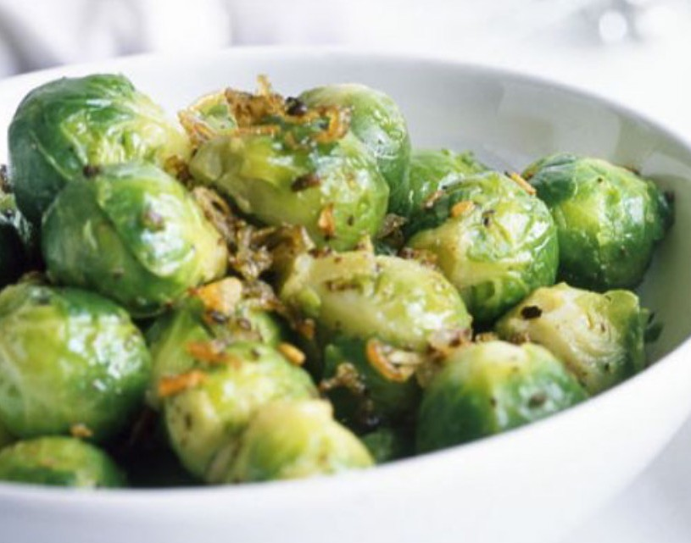
Shopping & Ingredients List:

750g fresh sprouts 20g butter
1 tbsp olive oil
25g wholemeal breadcrumbs
20g Parmesan cheese finely grated
Method
- Cut a cross in the bottom of the sprouts. Add the sprouts to a pan of boiling water
- Lower heat and simmer for 10mins
- Remove and drain
- Heat butter and oil together in frying pan and add the sprouts
- Sprinkle in the breadcrumbs and Parmesan cheese
- Mix carefully and fry over low heat for 2 minutes.

Serve immediatly

Macro info per serving
Protein
6g
Carbs
14g
Fat
7g
Energy
143kcal

The information provided in this book should not be relied on to suggest a course of treatment for an individual.

It should not be used in place of a visit to, consultation with or the advice of a doctor, or another qualified healthcare provider.

Discretion and common sense should be used.

Information in this book does not cover all/any aspects of medical health issues, ailments, allergies, or physical conditions or their treatment.

Should you have any health care related questions, call or see your doctor or another health care provider promptly. You should never disregard medical advice or delay in seeking it because of something you have read in thisbook.

Nutritional values in the meal planner / recipes are taken from third-party sources; due to differences in sizes, brands and localisation, nutritionalvalues may differ.

Always double check nutritional information and use common sense.

The book is provided without any warranty, and the use of the book is solely at your own risk.

Before relying on the material in this book, users should independently verify the accuracy, the completeness, and the relevance for their purposes, obtaining professional advice when appropriate or applicable as the material in the book may include opinions, recommendations, or content from third parties, which may not reflect your views.

By accepting and using the book and any information contained in the book you understand and acknowledge that everyone that has contributed or prepared this book disclaims any liability to you, and all such persons are not liable for losses or damages which may result through the use of the information, products, and service presented in this book or any other materials or information relating to the book.

The statements in this book have not been evaluated by any external authority. The recommendations are not intended to treat or cure any disease or condition.

